Comparing Portfolio Performances

Timothy Richman  
Jose Zuniga

Jing Shuai

Wei Dai

Paul-Richard Cherival

Zicklin School of Business

Abstract

The objective for all good fund manager is too maximize investor’s return while minimizing exposure and risk while, staying within the clients’ risk tolerance. Much research has been done in the research strategy and as result we know of several proven approaches to optimize any portfolio, however each model has its pros and cons depending on the situation. This paper will evaluate several investment strategies.

Keywords: Sharpe Ration, PCA, Maximum Drawdown, Bootstrapping

Comparing Portfolio Performances

# Motivation

With information and computational power easily accessible, there is great incentive for Portfolio managers to leverage these resources to maximize returns. In our paper we are going to construct portfolios using different approaches and using metrics such as Sharpe Ratio, Maximum Drawdown and Turn-Over Rate we will determine the best approach to maximize return.

**Investment Strategies.**  
**Minimum Variance Portfolio.**  
The Minimum Variance Portfolio model consists in allocating our investment budget towards our stocks in a manner which minimizes the overall risk of the portfolio.

**Tangency Portfolio with risk free asset**

The Tangency Portfolio with a risk free asset is a variation of the Minimum Variance Portfolio which introduces a risk free asset to help with minimize the portfolio’s exposure to risk.

**Capital Asset Pricing Model**

The Capital Asset Pricing Model, in addition to using a Risk Free Asset also takes into account the sensitivity of the assets in the portfolio to market variations.

**Parametric Bootstrap**

Parametric Bootstrapping consists and sampling with replacement in order to estimate the return and variance. Computation Heavy.  
**Target Return**

**Principal Component Analysis**

Principal Component Analysis consists in identifying the elements of a dataset which best explains the variance of a target. In the case of portfolio construction, the aim is to identify the stocks which contribute to the highest returns.

Each approach has its assumptions benefits and drawbacks.

Approach

In order to evaluate the different investment Strategies, we picked the Top 20 traded Stocks of the S&P500 and analyzed their returns over a 7 year period (Jan-1-07 – Dec-1-14). Since the aim is to evaluate the individual strategies it is important we use the same assets in each portfolio and we will use the listed stocks in all our investment strategies, Apple: AAPL, Exxon Mobil: XOM, Microsoft: MSFT, Johnson & Johnson: JNJ, General Electric: GE, Wells Fargo Company: WFC, Proctor & Gamble: PG, JP Morgan Chase: JPM, Chevron Corp.: CVX, Verizon: VZ, Pfizer: PFE, Intel: INTC, Bank of America: BAC, AT&T: T, Merck & Co: MRK, Coca Cola: KO, Citigroup: C, International Business Machines: IBM, Google: GOOGL, Gilead Sciences: GILD.

The stocks selected are well diversified and represent all the major industries.

**Portfolio Performances**

During the Period in review, the S&P500 had a 9% return with a standard deviation of 22% (Table 1). In spite of this positive return, each of our strategies outperformed the bench with our bootstrapping model providing us with an outstanding 71% return and MVP model being least risky with a 14% standard deviation.

**Risk Management**

**Take Away and Further Study**

With the stocks being constant across each portfolio in our analysis it became evident that each strategy had its positives and drawback. With this in mind we are able to tailor portfolios to meet clients’ long and short term goals. Moreover, understanding how each strategy performs under various market conditions will help optimize when to

References

Last Name, F. M. (Year). Article Title. *Journal Title*, Pages From - To.

Last Name, F. M. (Year). *Book Title.* City Name: Publisher Name.

R Code

Tables Performance Summary

Table 1

S&P500 Bench

* Period
* start = "2007-01-01"
* end = "2014-12-01"
* SPDR S&P 500 ETF (SPY)
* Mean = 0.09166378
* Standard Deviation = 0.2224576
* Sharpe Ratio = 0.3221458
* Maximum Draw Down = 1.852949
* Turnover Rate = Pending

MVP

* Mean = 0.09305468
* Standard Deviation = 0.1450562
* Sharpe Ratio = 0.5036302
* Maximum Draw Down = 2.968063
* Turnover Rate = Pending

Tangency Portfolio with Risk Free Asset

* Mean = 0.34323781
* Standard Deviation = 0.3051219
* Sharpe Ratio = 1.0593728
* Maximum Draw Down = 1.794105
* Turnover Rate = Pending

Parametric Bootstrap Tangent Portfolio

* Resamples = 10^5
* Time @ 1.8 GHz = 10.46968 mins
* Robust Mean (0.05 Trim) = 0.71230152
* [1] 0.5782493 8.7699115
* [1] -0.5066259 -0.5012057 -0.5030242 -0.4965201 -0.8548569
* Standard Deviation = 0.5486998
* Sharpe Ratio = 1.2617126
* Maximum Draw Down = 3.056742
* Turnover Rate = Pending

Target Return Portfolio

* Mean = 0.5
* Standard Deviation = 0.4601001
* Sharpe Ratio = 1.0432513
* Maximum Draw Down = 1.765257
* Turnover Rate = Pending

Principal Component Analysis Model

* Mean = 0.16556244
* Standard Deviation = 0.1307560
* Sharpe Ratio = 1.1132370
* Maximum Draw Down = 1.615135
* Turnover Rate = Pending

Tangency Plot

Benchmark

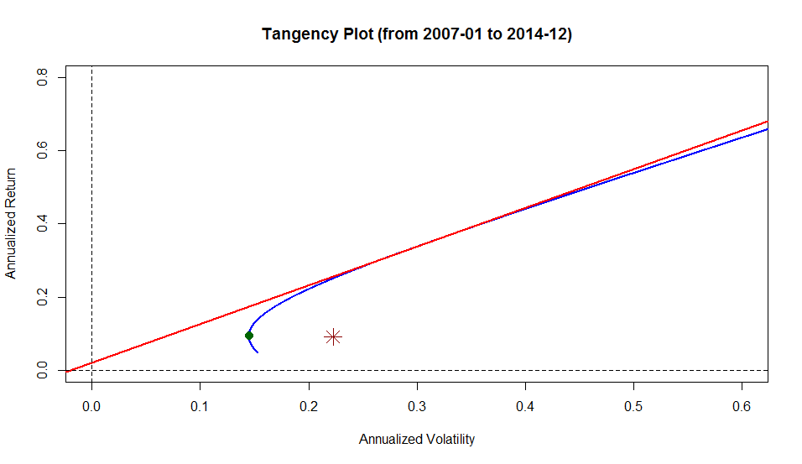

MVP Model



Tangency Portfolio

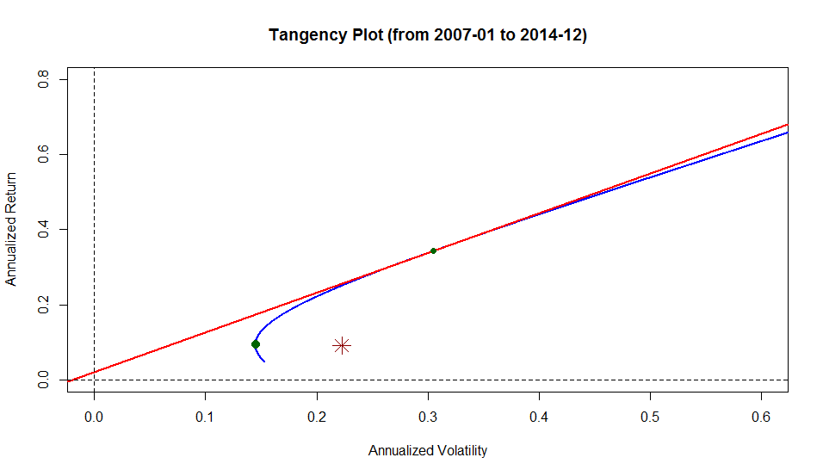

Parametric Boostrap  
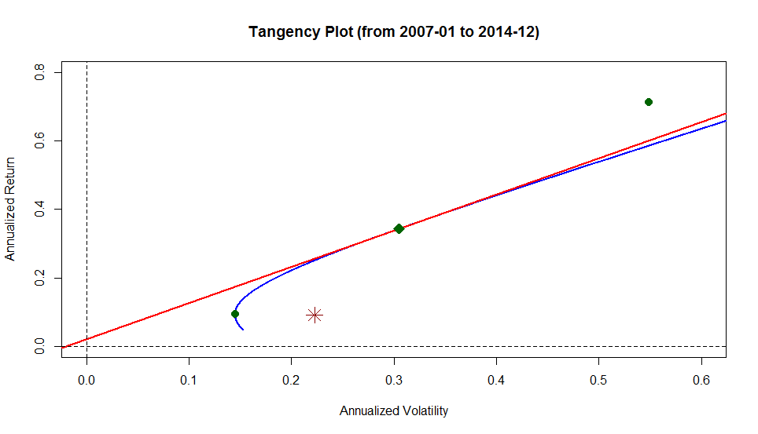

Target Return  
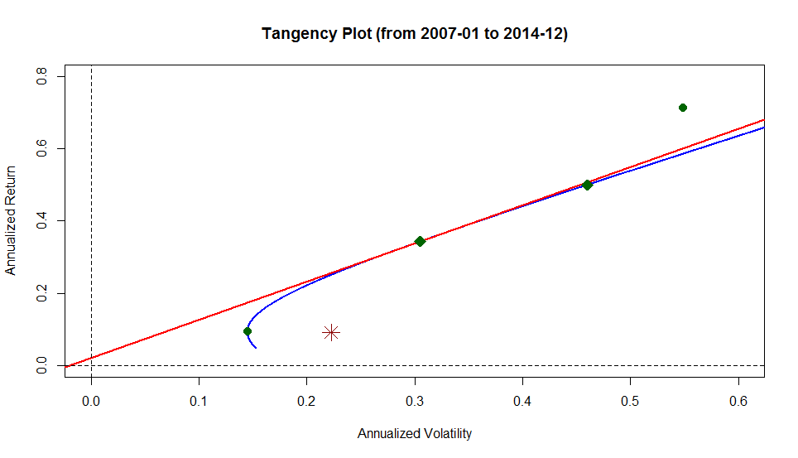

Target Return With risk Free Portfolio  
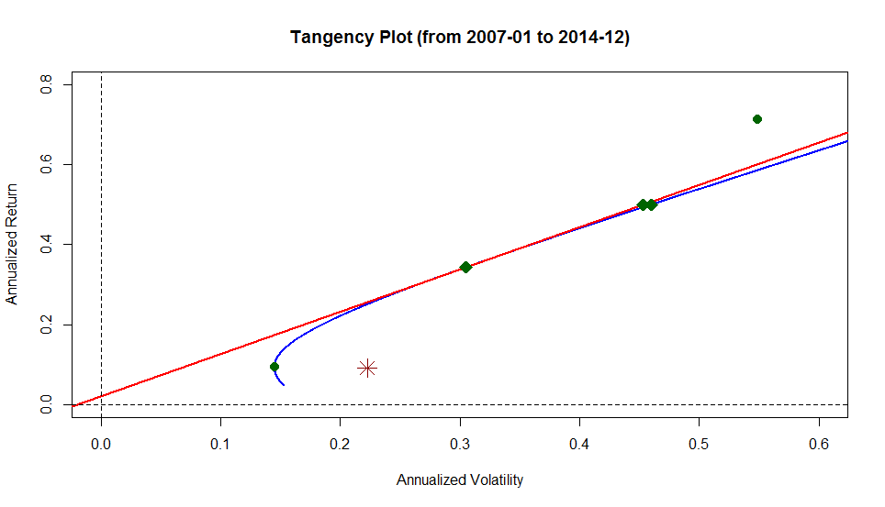

Principal Component Analysis

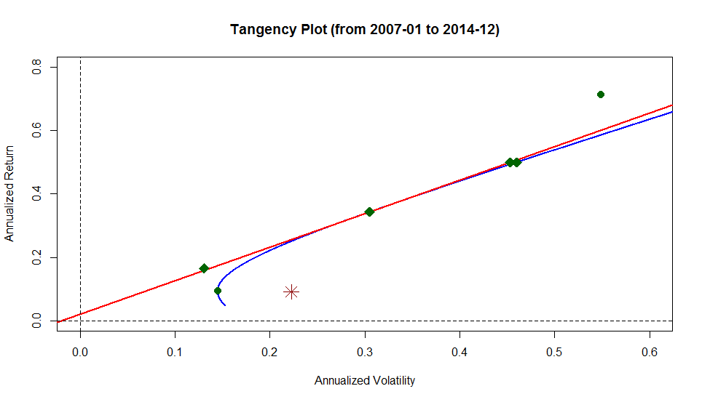

In Memory

of

Timothy Richman

11/22/1982 – 11/28/2014